**Name: Gaurav Dhavale NetID: gdd160130 SAP HANA ID: GBI_269**

**Views Screenshots**

**Attribute Views**

**AT_PLAYER**

**DATA FOUNDATION**

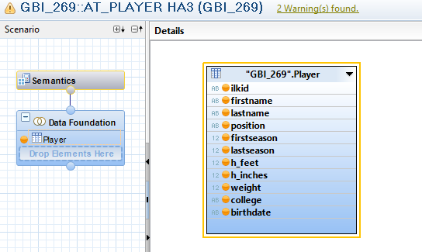

**SEMANTICS**

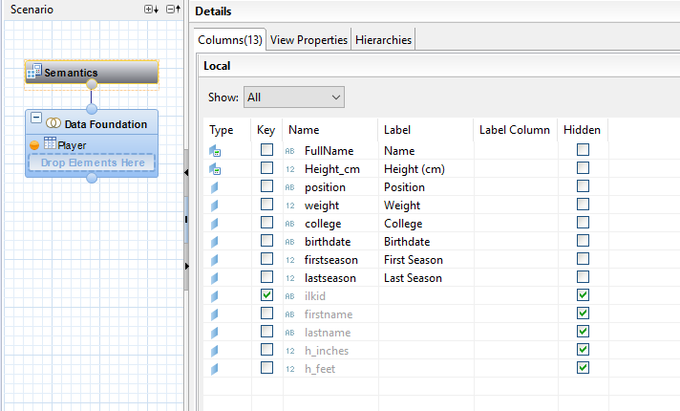

**RAW DATA**

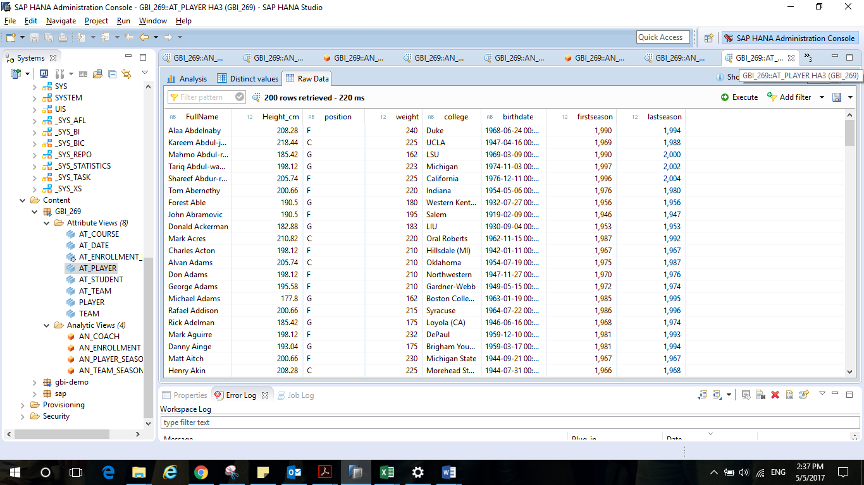

**AT_TEAM**

**DATA FOUNDATION**

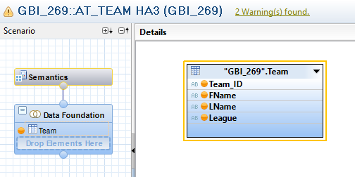

**SEMANTICS**

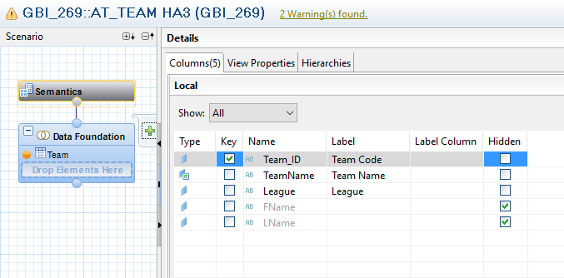

**RAW DATA**

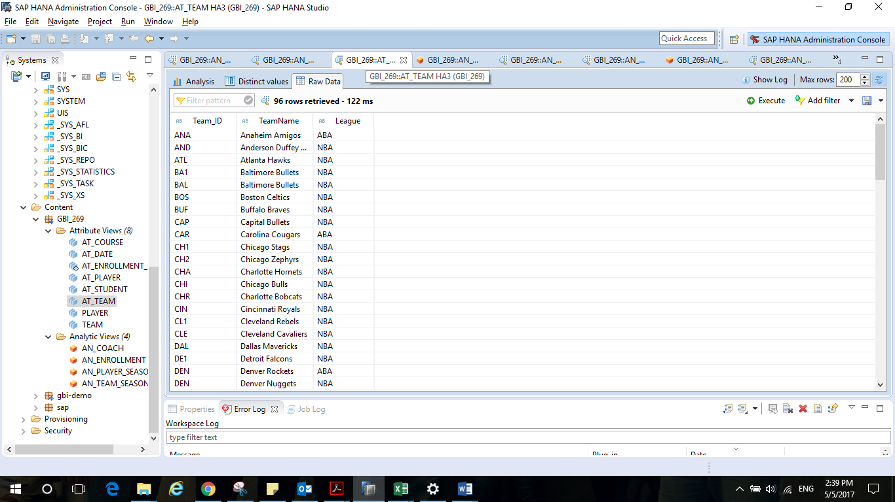

**Analytic Views**

**AN_TEAM_SEASON**

**STAR JOIN**

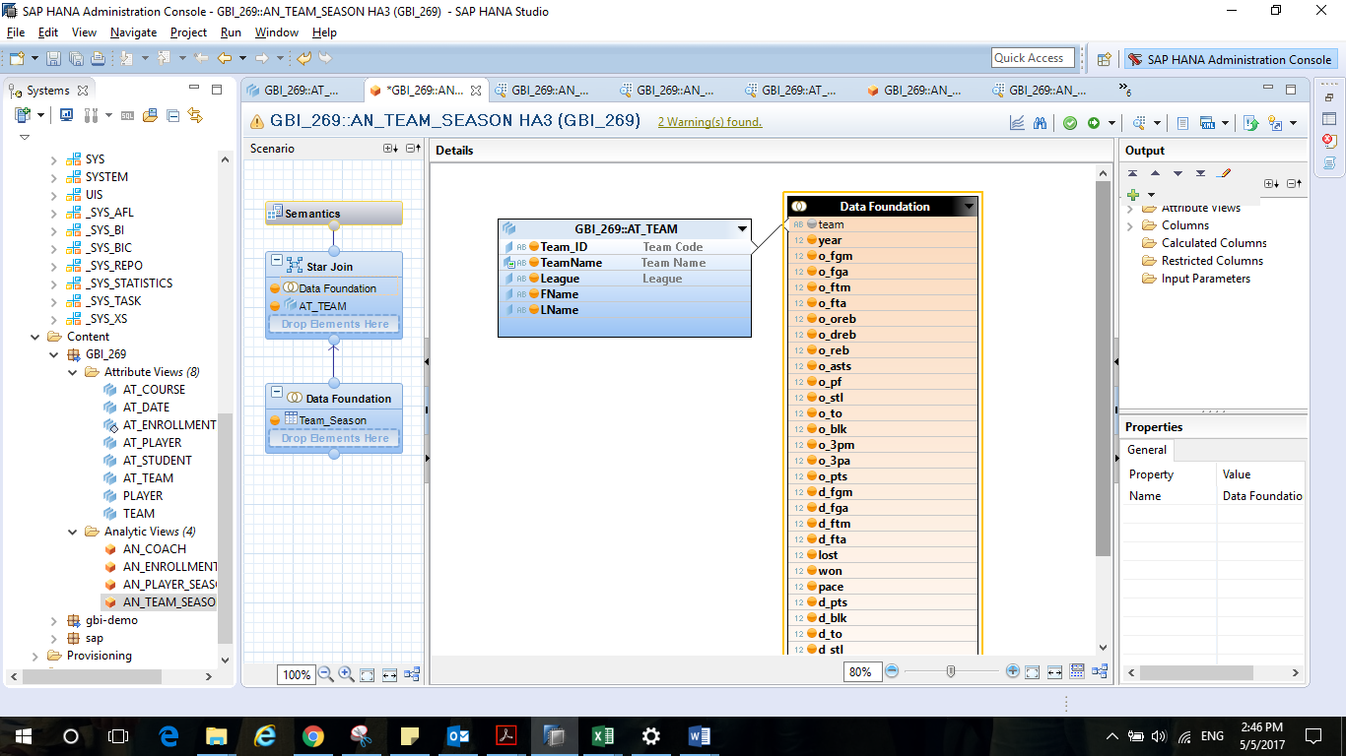

**SEMANTICS**

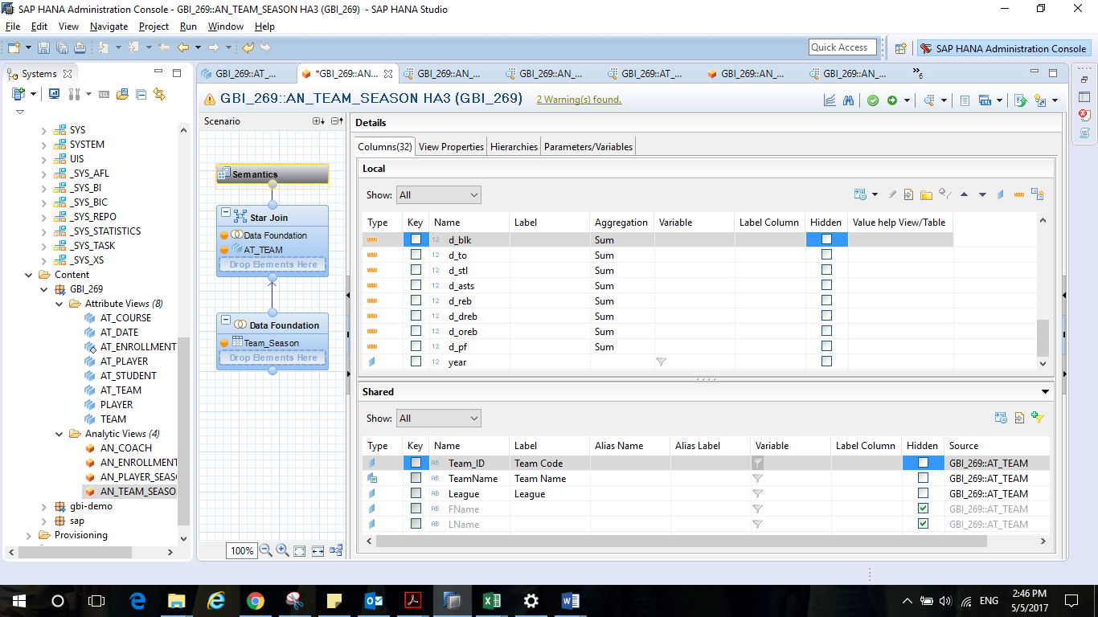

**RAW DATA**

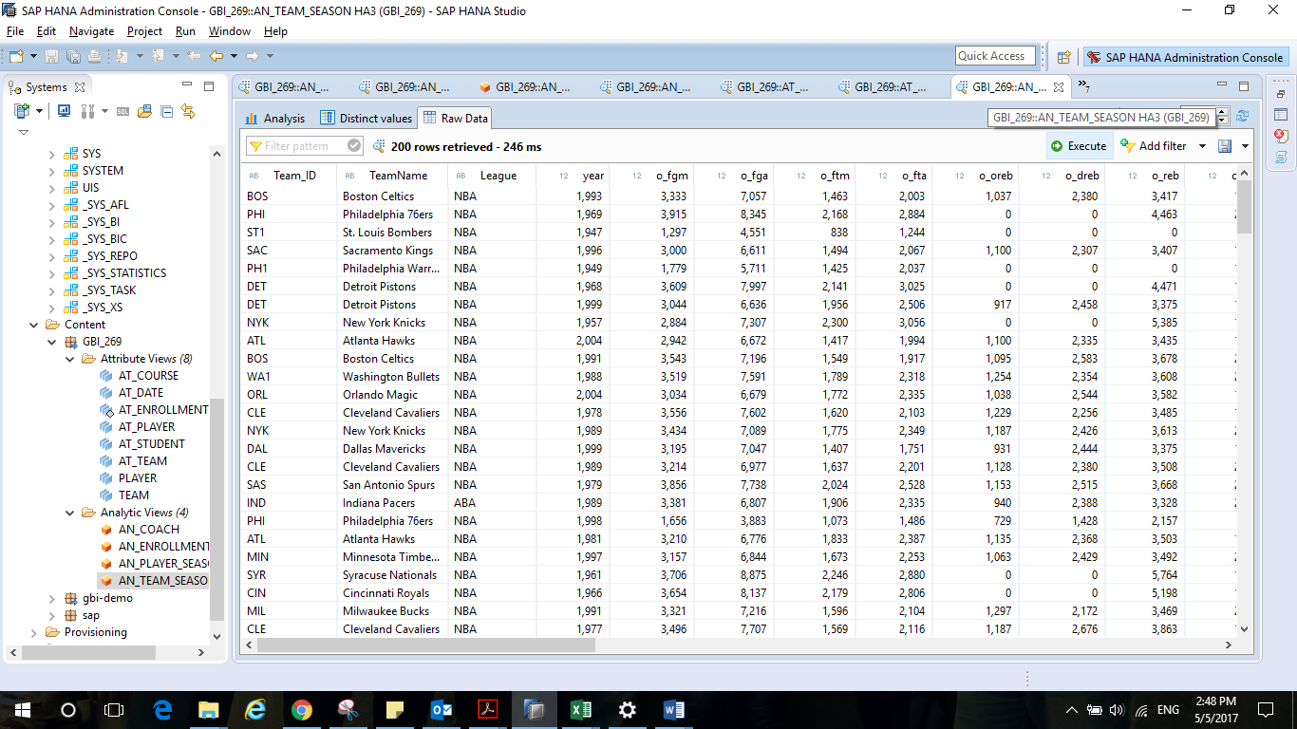

**AN_PLAYER_SEASON**

**STAR JOIN**

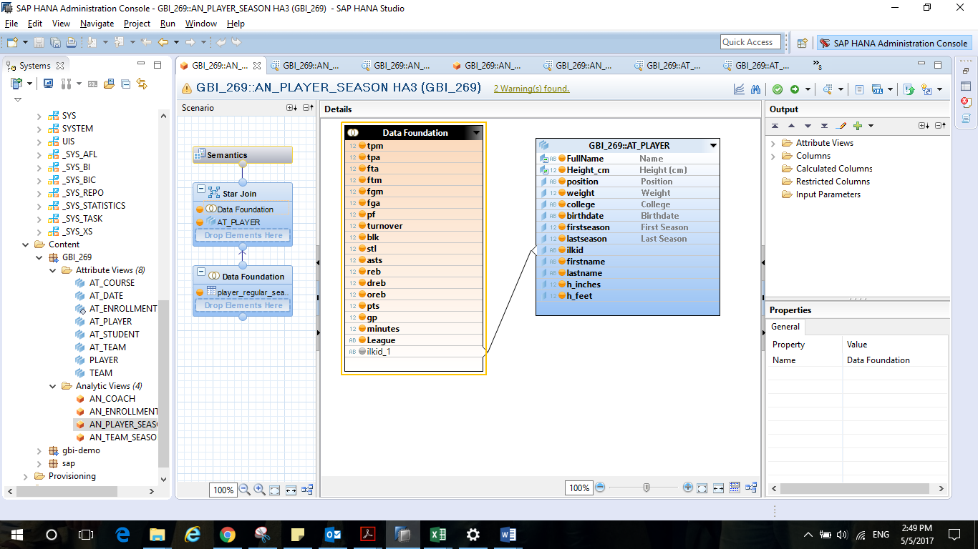

**SEMANTICS**

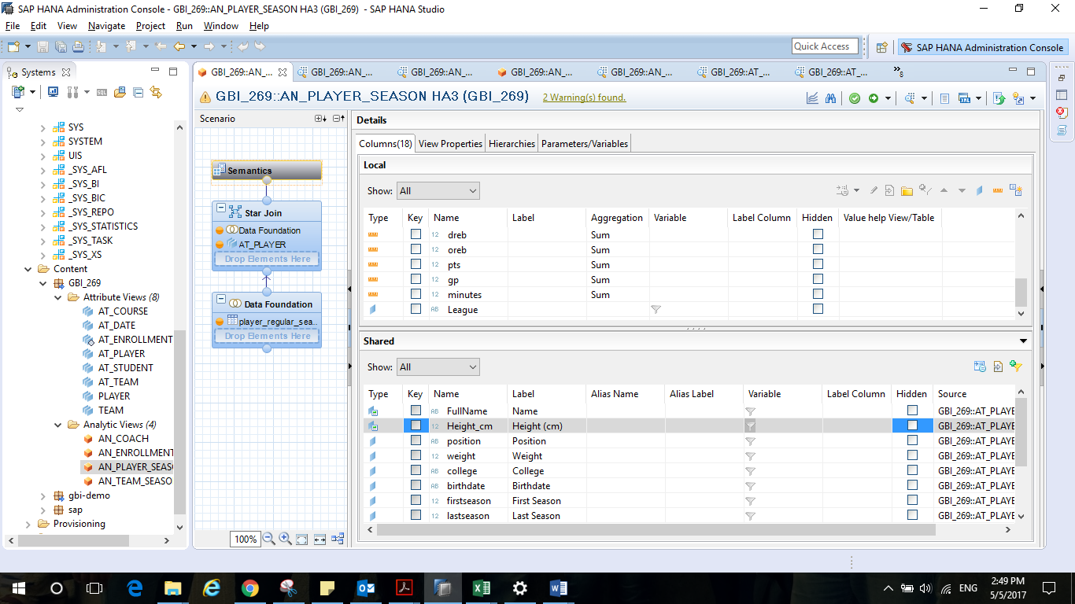

**RAW DATA** 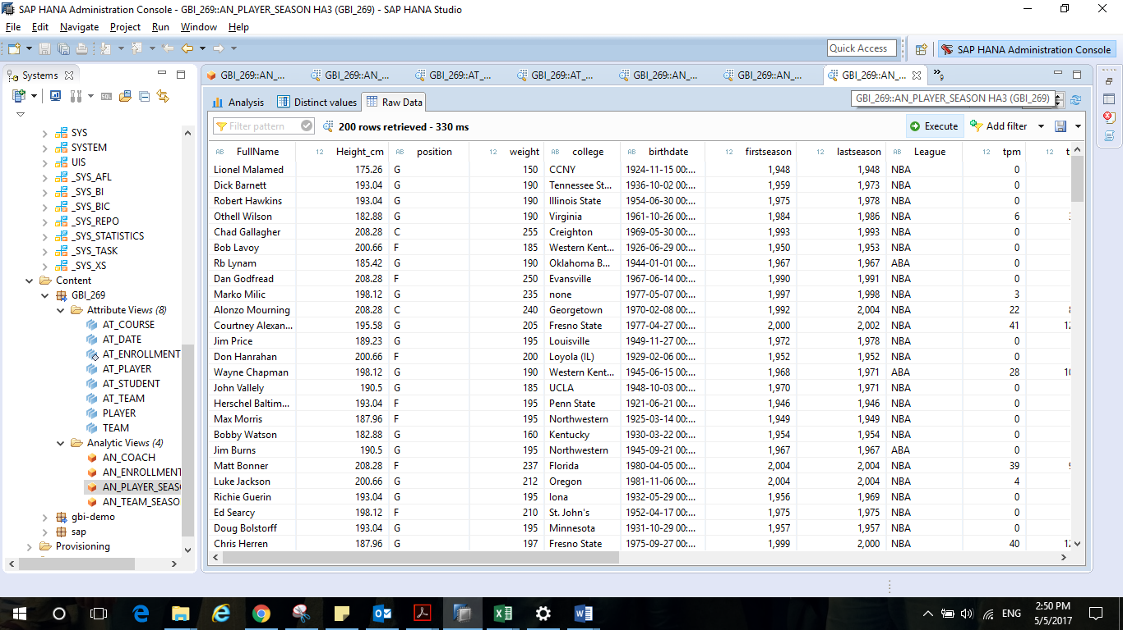

**AN_COACH**

**STAR JOIN**

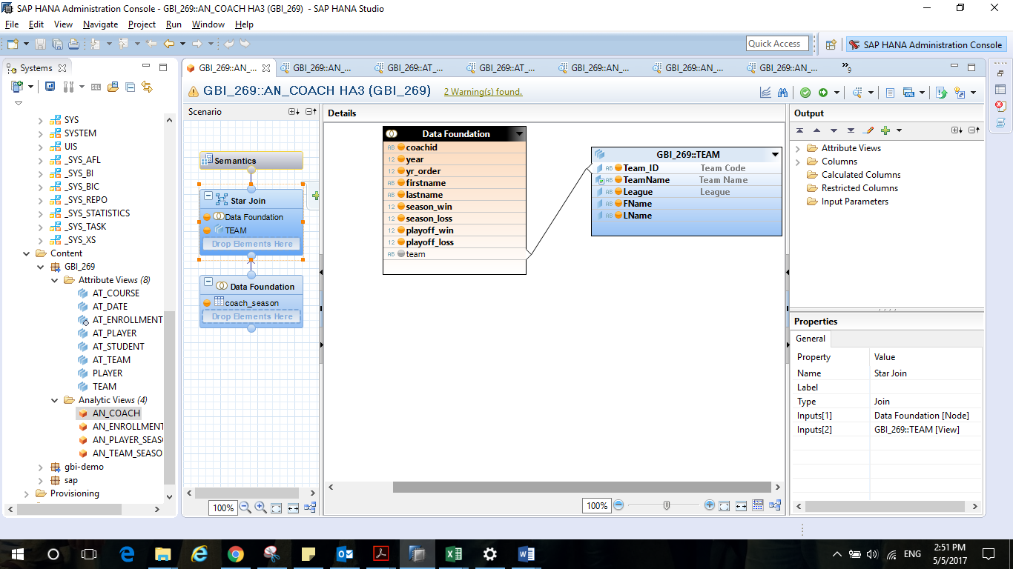

**SEMANTICS**

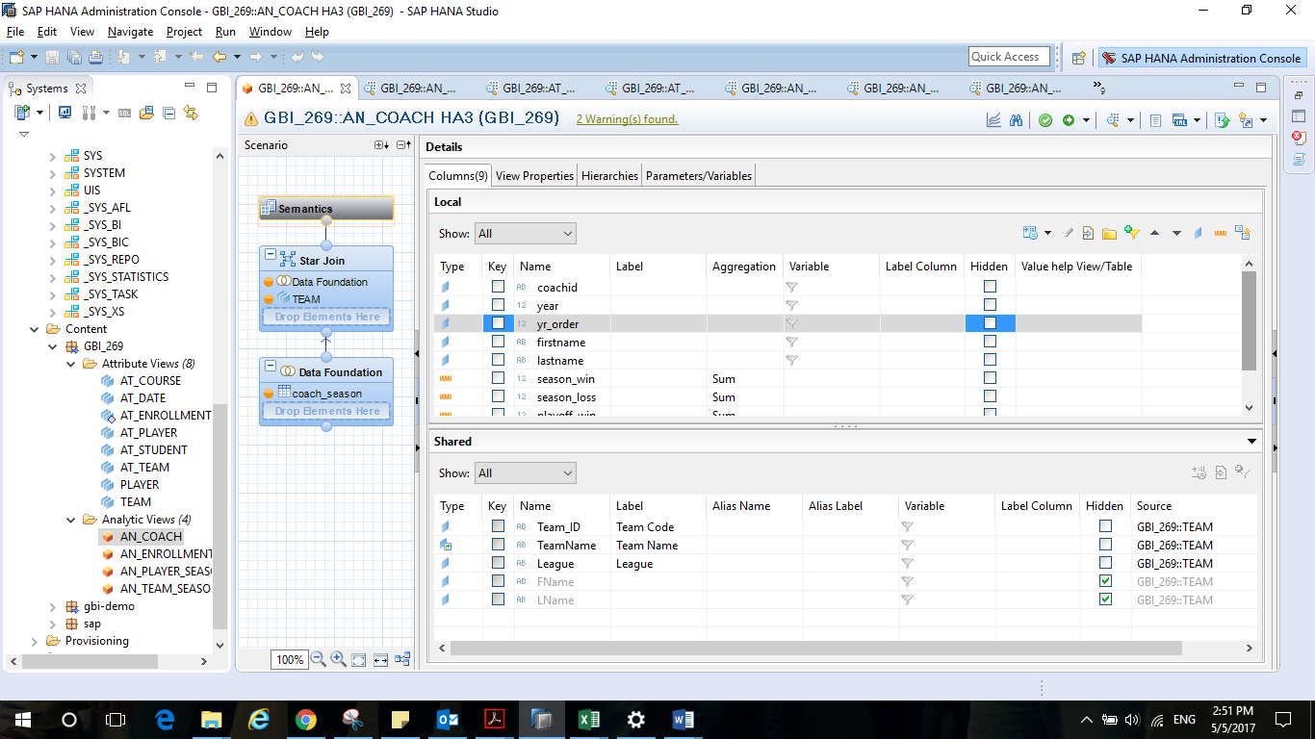

**RAW DATA**

